MAT_SCI 360
Introduction to Electron Microscopy
Spring 2023

Laboratory 4:

Introduction to SEM, Specimen Preparation, Objective Aperture, Working Distance, and Condenser Lenses

Introduction
This laboratory is designed to introduce the Hitachi S-3400 Scanning Electron Microscope. In this initial laboratory, the methods for basic operation and alignment of the instrument will be covered. You will also investigate methods for sample preparation and look at the effects of objective apertures, working distance and condenser lens strength. The purpose of this lab is to get you familiar with the standard operation of the SEM and general facility practices.
As you know from the course lectures, SEM provides the means to generate and analyze myriad signals generated from electron-specimen interactions. Of all these signals, the most commonly used imaging signal is the secondary electron (SE) signal. For this first laboratory, we will only be imaging with the SE signal in SEM, but we will explore other signals in the second laboratory.

Learning Objectives: By the end of this laboratory session, you should be able to:

- Understand how to prepare and mount both conductive and insulating samples for examination.
- Start, load samples and align the Hitachi S-3400 SEM and explain the effects of the alignment upon the imaging conditions
- Increase the resolution of the SEM image through the use of the condenser lenses and explain this increase in terms of electron optics.
- Adjust the depth of focus and resolution using the objective aperture and working distance and explain the mechanism that causes this effect.

Part I: Specimen Preparation
In general, samples for the SEM must be both dry and electrically conductive. Since SEM imaging involves bombarding a material with an electron beam, the surface of the sample will accumulate charge if the electrons are not allowed to escape from the surface via a conductive path. If there is no such path, the image formed by the SEM will often be very poor, exhibiting imaging artifacts such as streaks, loss of contrast, distortion, etc. Charging can also lead to excessive heating of the sample, causing material degradation. Insulating and semiconducting materials (i.e. ceramics, polymers, and organics) should be coated with a conductive material to prevent surface charging - specimens are typically coated with either a metal or carbon. Also, as the SEM is generally a high vacuum instrument, samples that contain water or other volatile components should be avoided as they may outgas in the chamber, which can cause imaging problems and potentially contaminate the chamber. The Hitachi S-3400 SEM is an Environmental SEM (ESEM) and is capable of imaging non-conductive samples without coating. We won’t use the ESEM mode for these labs, but this may be useful for your final projects or future research.
As part of this laboratory, you will be introduced to some of the basic sample preparation techniques and equipment found in EPIC. The most important sample preparation equipment for SEM includes the sputter coater, osmium coater, critical point drier and plasma cleaner. All of this equipment is available for use on your final projects.

Part II: Starting up the Microscope
Even though SEM's are expensive and technically advanced analytical tools, don't let them be intimidating. The S-3400 has a user-friendly interface. Remember the following:

- Begin your sessions by checking that the Vacuum Mode is in the SEM position in the Cond. tab (right side of screen), and the beam blanker to the right of the microscope is in the ON (not EXT) position. The S-3400 can be used in VP-SEM mode for experiments that require low vacuum; we will not use that mode in this lab.
- Pay close attention to your sample height and link focus height to the stage Z control. After the sample is mounted in the sample holder, use the sample gauge to measure both the Height and Size (width). Enter these values into the dialog box after you insert the sample holder into the chamber, rounding up to the next value if the true size is between two choices. This step is critical to prevent crashing your sample into the objective lens or BSE detector while operating the microscope.
- Vent the chamber by pressing the AIR button on the front of the SEM. The chamber is vented when it beeps softly three times. You can then load your sample holder onto the stage, close the chamber door, and press EVAC.
- Shortly after turning on the beam or changing the kV, auto-saturate the filament using the AFS button in the Optics Setup window.
Today’s lab will focus on how the conditions you select will effect imaging in the microscope. For general operation instructions, please refer to the S-3400 standard operating procedures. These instructions can be found on the course website and a copy is always available at the instrument.

Part III: Aligning the Microscope Column
In order to obtain good resolution, it is essential that the microscope be properly aligned. As you select different apertures, condenser lens settings (“spot size”), and operating voltages you will need to adjust your microscope alignments to get the best possible image. Ideal alignment is achieved when the gun, lenses, and apertures are concentric about the optic axis - an imaginary line drawn down the center of the column. There are five basic procedures we need to complete, which are detailed in the manual and outlined below:

- Adjust sample height: For higher resolution imaging, the sample must be closer to the lens. From the Stage menu on the right, select Analysis to send the stage to a working distance of 10 mm. NOTE: Keep an eye on the chamber scope! Hit STOP if your sample gets too close to the lens.
- Align the objective aperture: This is best accomplished when you are focused on a recognizable feature using a relatively fast scan speed (300ns). The aperture alignment can be in the Alignment menu 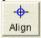. When Aperture Align is selected, the focus wobble is activated automatically. The system is modulating the focus of the objective lens and aperture misalignment is seen as an image shift. To correct the aperture misalignment, adjust the X and Y Stigma/Alignment knobs to minimize translation of the image.
- Align the beam: Select Beam Align. Tilt and adjust the X and Y Stigma/Alignment knobs, one at a time, until you find the brightest image possible. Repeat for Beam Align. Shift.

- Stigmator Centering: In order to adequately correct for astigmatism, it is important that the beam is properly centered in the stigmator assembly. For both the X and Y stigmator centering, use the Stigma/Alignment knobs to minimize translation of the image.

- Correct for astigmatism: Once the stigmators have been aligned, you can adjust the strength of each stigmator independently to correct for astigmatism. You are looking for the sharpest image and should see no stretching of the image when changing focus.

Make sure you are comfortable with the alignment procedure as you will need to re-align after each change in imaging conditions below.

Part IV: Depth of Focus
The objective aperture plays a role in determining the depth of focus in SEM images. Depth of focus is the total range of height that can remain in focus at a given time. One of the primary advantages of SEM is the large depth of focus that may be achieved in the images compared to optical microscopy. For example, the study of fracture surfaces in failure analysis typically involves imaging of very rough surfaces with large peaks and valleys. The SEM is particularly well suited to imaging such features. The reason that there can be a range of depth in focus at a single time is illustrated in the following figure (from Goldstein et al., 115):

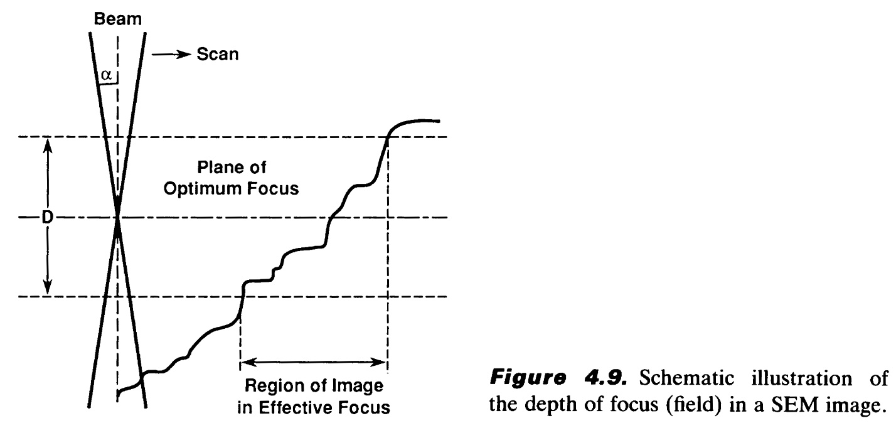
You can see that even though there is only one plane of optimum focus, there is a range of height over which the probe will still be small enough that the image will appear to be focused. You can see that by making the angle α smaller, the depth of focus can be increased. This can be achieved by adjusting either the objective aperture size or working distance.

In order to image the entire surface at one time, you will need to control the depth of focus. Today you will be imaging a calibration grid with 2160 lines/mm which has been mounted on a pre-tilted SEM holder at 70° (from horizontal). To see the effects of objective aperture size on depth of focus, image the sample with the beam at 10kV using spot size 4, aperture #3 (dia. = 50 μm) and aperture #4 (dia. = 40 μm). You will want to use a short working distance (~5 mm) and select a magnification such that you can visualize the region of good focus within the field of view (i.e. you should see blurry regions at the top and bottom of the image and a discernible clear region in the center). Make sure to record the working distance, aperture size, and magnification for each micrograph so that you may calculate the corresponding theoretical depth of field. (Note: Remember to realign the system each time you change parameters.)

Part V: Controlling Resolution with the Condenser Lens and Objective Apertures
Since the SEM uses an electron probe to scan in the image of our sample point-by-point, the diameter of the electron probe contributes to the resolution of that image. That is, the smallest feature we can resolve (image resolution) is limited by size of the electron beam at the sample (and the beam interaction volume). One way to control the diameter of the electron beam, or probe size, is by manipulating the condenser lenses (spot size). The purpose of the condenser lenses is to demagnify the probe coming from the electron gun. The effect of the condenser lenses on the probe size is illustrated in the figure below (from Goldstein et al., 47):

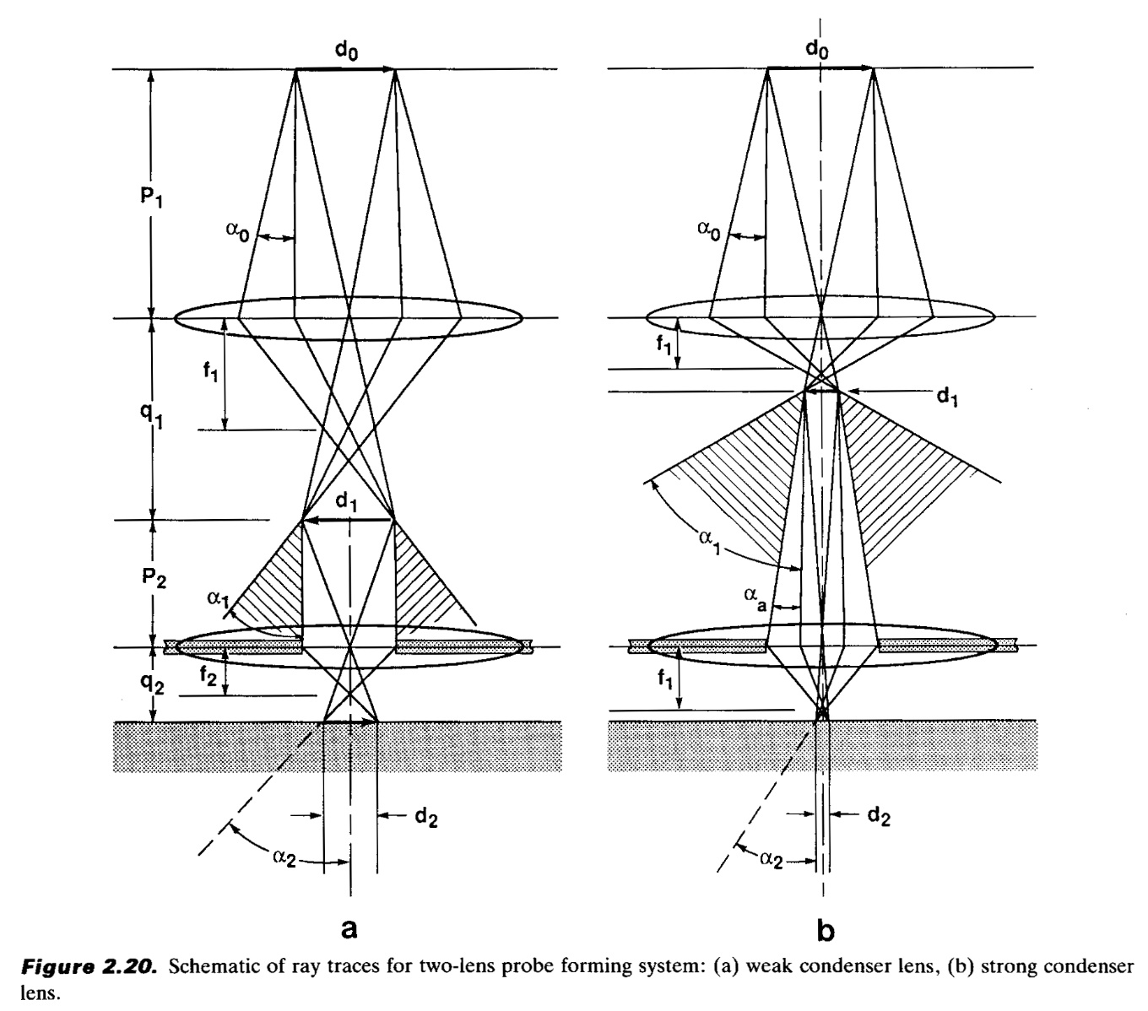
From the diagram, you can see that for a given working distance and objective aperture size, a stronger condenser lens will produce a smaller electron probe size, hence higher image resolution. However, you should also notice that the stronger condenser lens setting results in a lower probe current, indicated by the larger crosshatched area (more electrons are being “thrown away” from the beam). In electron imaging, this loss of probe current will be seen as a picture with more “snow” or “noise”. This is the trade-off that you will encounter over and over in using electron probe instruments - spatial resolution versus sensitivity.

To visualize these effects, take two different pictures of the same region on the sample (Au on Carbon resolution standard) with different condenser lens settings. Take one image with a spot size setting of 2 and another with a spot size of 5. Use an accelerating voltage of 30kV, magnification >20,000X, working distance of <10mm and aperture #4 for both images. (Note: You will need to realign the column after each change to the condenser lens strength.)

You just used the condenser lens strengths to change the resolution of the SEM. Resolution can also be improved through the use of the objective aperture. The effect of the objective aperture on probe size is illustrated in the figure below (from Goldstein et al., 50):

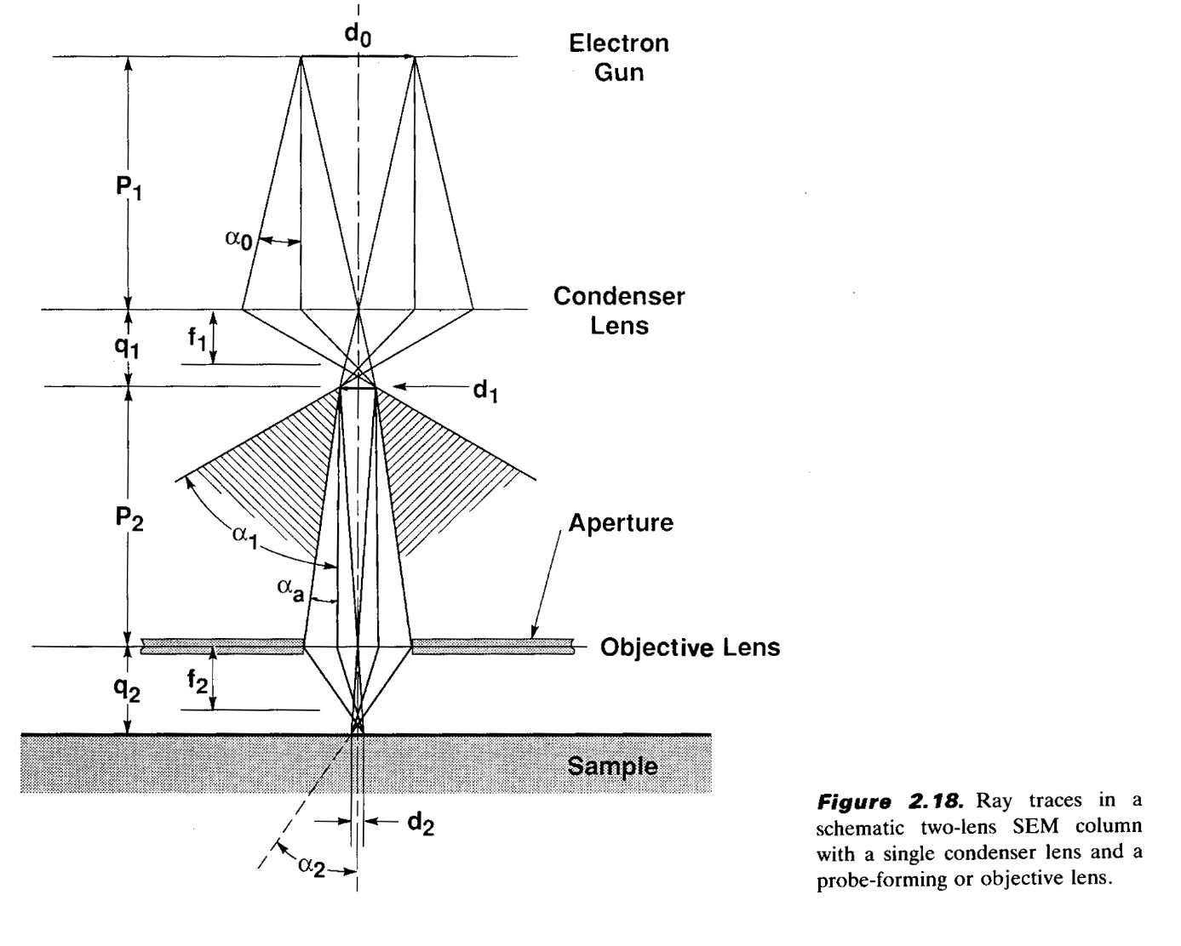
As you can see, the objective aperture effectively decreases the amount of the objective lens that is used to focus the beam on the sample. Moreover, the aperture limits the area of the objective lens used to the center portion of the lens. This has the effect of minimizing the detrimental effects of the objective lens aberrations (primarily astigmatism and C_{S}) on the final imaging probe. This will improve the resolution of the microscope by allowing you to form a smaller probe at the sample surface. However, a smaller aperture also results in a lower probe current which results in lower sensitivity.
Keeping the spot size set to 2, change the aperture to #6 (30µm) and capture another image. Remember to realign the aperture after the change in aperture size. Be sure to record the aperture, working distance, and accelerating voltage of each picture taken. Discuss and try to show the effects of condenser settings and aperture size on resolution, but at the expense of signal to noise ratio in the three micrographs in this section.

Tangibles:

Laboratory report #1 is due one week after your laboratory session and is to be turned into the T.A. Each group should hand in one laboratory report for all members. In laboratory reports you should be prepared to hand in the following:

1. Laboratory report, typewritten in standard laboratory report format including sections: Introduction, Procedure, Results and Discussion, Conclusion and References. The introduction should include motivations for the laboratory and background information on pertinent aspects of the laboratory (i.e., electron optical alignment, charging, etc.). It is not necessary to detail step-by-step operational procedures in the Procedure section, but instead discuss important steps in a more general or bullet form. Be concise and succinct.

2. Include all micrographs taken in this laboratory, appropriately labeled with detailed explanations in the Results and Discussion section of the report. The images captured with the SEM will be in a digital format, so please bring a flash drive to retrieve your data. The handouts and your textbook should be sufficient for you to interpret your results, but you should provide an explanation in your own words.

The report is due one week after the lab. Submit via email in MS Word format or as PDF.

References
- Joseph I. Goldstein et al., Scanning Electron Microscopy and X-Ray Microanalysis, 3rd ed., (New York: Springer, 2003).

