MAT_SCI 360
Introduction to Electron Microscopy
Spring 2023

TEM Laboratory 2:

Selected Area Electron Diffraction and Kikuchi Lines

Introduction
This laboratory is designed to introduce one of the TEM techniques, selected-area electron diffraction (SAED). In this laboratory, you will learn to acquire SAED patterns from a single crystal. From a single crystal, a spot pattern can be obtained, as comparing to a ring pattern obtained from a polycrystalline sample and a diffused pattern from amorphous materials. You will realize that the relative orientation between the single crystal and the incident electron beam is very important to acquire ‘useful’ electron diffraction. The orientation when the crystal displays high symmetry is called low-order zone axis. Kikuchi lines and Kikuchi pattern are useful in identifying crystals’ orientation.

Learning Objectives: By the end of this laboratory session, you should be able to:

- Understand how to use the selected-area aperture to acquire SAED patterns.
- Tilt a single crystal inside the TEM by using a double tilt holder to align the crystal so that one of its low-order zone axes is in the direction of beam direction (TEM optical axis).
- Tilt the single crystal from one low-order zone axis to another low order zone axis.
- Calculate the experimental angle between two zone axis giving experimental readings from the double-tilt holder.
- Calculate d-spacing for a given diffraction spot. Calculate/measure angle between two lattice planes, related to two diffraction spots in the pattern. Index the diffraction patterns and determine the zone axis.
- Calculate the theoretical angle between two zone axis.

Lab Background: Review of some basic principals you learnt from the class:

- Electron diffraction: When we are interested in the form of the electron wave at a distance far from the specimen (specifically, a distance far larger than the dimension of the specimen), Fraunhofer diffraction is the most pertinent approximation for electron diffraction and imaging. In an electron microscope we can use the magnetic lenses to go to an effective infinite distance from the specimen by looking at the diffraction pattern.
- Scattering from a single atom: is also called atomic scattering factor. As rule the atomic scattering factors are smoothly decaying functions as a function of the scattering vector (g in reciprocal space).
- Diffraction/scattering of a line of N point scatterers: Considering the electron wave scattered by a line of atoms separated by a distance a. The ‘diffraction pattern” has a number of peaks centered on the positions n/a, (n is the peak number); each of which has a width proportional to 1/Na.
- Diffraction of crystal (infinite 3D scatters in a repeated lattice defined by an unit cell) generates a reciprocal lattice in reciprocal space, obeying the Bragg’s law. In the geometry in reciprocal space, the Bragg’s law can be described as the intersection of the reciprocal lattice and the Ewald sphere. Examples of spots patterns of a face-centered cubic crystal are shown in fig.1.
- The intensity of a diffraction spot (corresponding to a set of lattice planes in real space) is determined by structure factor of the unit cell, under kinemical scattering theory (when multiple scattering effects can be ignored for a very thin specimen).
- Kikuchi lines are generated by the inelastically-scattered electron: they are more sensitive to the crystalline orientation than diffraction spots. Kikuchi pattern is like the stereographic projection for the crystal, as shown in fig.2. The intersecting points of many Kikuchi lines correspond to a high symmetry zone axis of the crystal, which is low-order zone axis.
- When we tilt a crystal by following a certain Kikuchi line (hkl), it equivalents that we tilt the crystal in real space with the [hkl] zone axis as the tilting axis.

Laboratory procedures:

Aims: The aim of this lab is to familiarize you with selected-area electron diffraction in TEM. This lab covers:
- Selected area electron diffraction
- Kikuchi pattern and tilt the crystal along the Kikuchi line
- Index Kikuchi and diffraction patterns.

TEM: JEOL 2100F; double tilt holder
Sample: Si

I.1. Specimen tilt

1). You need to use a double tilt specimen holder to tilt the specimen to a zone axis orientation.
2). Make sure that the specimen is at the eucentric height before tilting it – this makes it much easier as well as safer (clear of the objective and SA apertures if present).
3). To monitor the specimen tilting, you want to keep an eye on the diffraction pattern formed from a reasonable thick area using a convergent beam while you tilt. This requires some hand-eye co-ordination, and you have to work out for yourself what works best for you. Until you are familiar with the process, it is probably better to only use one tilt at a time (not both simultaneously).
4). Figure out the relationship between the diffraction pattern changes and the direction(s) which you are tilting.
5). Keep the interesting area (at least one you hope is interesting) centered using the translates. You may want to stop the tilting, go back to imaging and look at the region that you have from time to time.

I.2. SAED patterns and Kikuchi lines

1). Make sure that the image of the interesting area is present on the screen in selected area mode.
2). Make sure that the diffraction pattern is properly focused – but not with convergent illumination, rather defocused (i.e. close to parallel) illumination.
3). If you cannot see Kikuchi lines on the screen, try a thicker area.

II Tilting experimental procedure

- Find an interesting thin area and set it at the eucentric height
- Focus beam to the area and press SA/Diff (right panel) to get a convergent electron beam diffraction pattern
- Look for the Kikuchi line and tilt the crystal to a low-order zone axis, where many Kikuchi lines intersect.
- Insert and center a suitable SA aperture
- If the central spot is not at the viewing center, center it by selecting PLA and then using the DEF/STIG X and Y knobs (left sub panel). Focus the pattern using DIFF FOCUS.
- Open the beam to form a parallel illumination on the sample by turning Brightness counterclockwise. Diffraction spots will become weaker and smaller. If the central spot is still a disk instead of a spot, diffraction focus is needed.
- Use the smallest possible exposure time to view the diffraction pattern with Gatan CMOS camera, RIO. Block the transmitted beam with the beam stop, if necessary, when the diffraction pattern is acquired. Or to make the spots weak by turning BRIGHTNESS and use a short exposure time (<0.5 second) to record the pattern with the camera. Attention: A high density beam (the bright transmitted spot) will damage the camera.
- NOTE: The MAG/CAM L knob varies the normal magnification when the MAG1 or MAG2 switch is pressed, and the low magnification when the LOW MAG switch is pressed; and varies the selected area magnification when SA MAG is selected and the camera length when SA DIFF is selected. Turning this knob clockwise increases the magnification or camera length and turning it counterclockwise decreases the magnification or camera length.

Laboratory Questions:
In your laboratory report you should provide a description of all micrographs taken and a concise discussion of differences you see. The handouts and your textbook should be sufficient for you to interpret your results, but you should provide an explanation in your own words. It is recommended to section your report into different sections including Introduction, Experimental, Results, and Discussion etc.
In your Experimental section, you will need to
1). Record one spot-diffraction pattern along a low-order zone axis.
2). Tilt the crystal from one low-order zone axis to the other zone axis; and acquire diffraction patterns; record the experimental tilting angles.
Fig.1. Six low-order zone axis spots patterns of a face-centered cubic crystal.
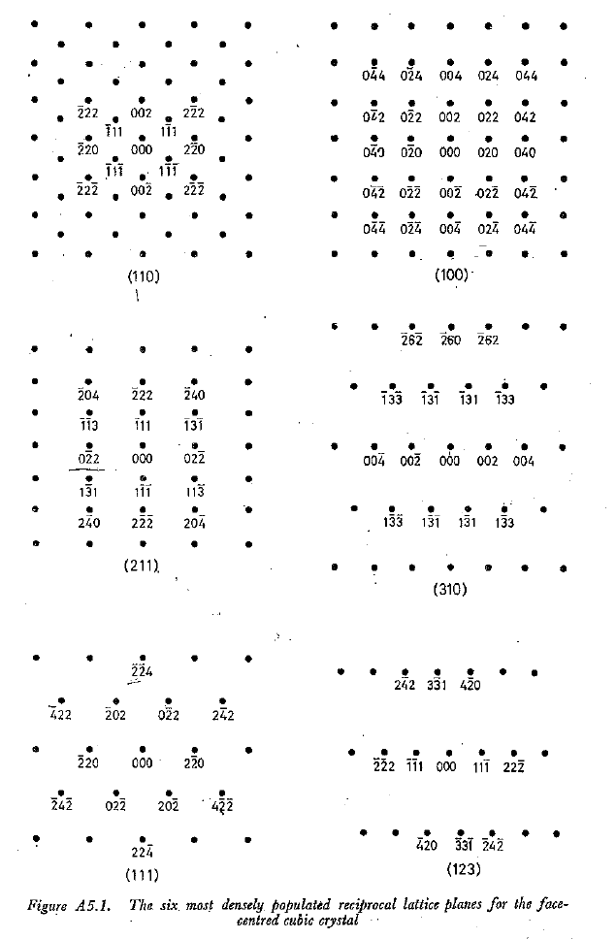
Fig.2. Illustration of Kikuchi patterns of a cubic crystal in the [011]-[001]-[101] corner.
