Computer Lab #3, Due Monday November 4th

1. Run through the “GITO Example”. The results may not be the same as the EDM code has changed. Compare your results to what is in the example (above).
2. Do exercise 8.1 in the edm documentation.
3. Do exercise 8.2 in the edm documentation.
4. Using NCEMSS, obtain a multislice image that comes close to the qphase reconstruction.

To Get Started with NCEMSS

The (free) NCEMSS code was a good idea, but ran into some political and legal problems. It works, but is not as user friendly as it could (should) be. As a quick guide:

1. Start X, and a cygwin shell
2. Do “cd /usr/local/edm/edm_test”
3. Type in “ncemss”
4. Click on the window with the source information (otherwise it won’t go away).
5. Click on “Single Structure”
6. Click on “Use Displayed File”, then “CaCl2” (I know it is odd, but….)

The strategy from here is to Click on the relevant rectangle to do anything. So, as a simple test

a. Click on “Change”, Go to Volt and change this to 200 (with a Carriage Return)
b. Click on Defocus and type in -100,-700,-200 (which means start at -100 and go to -700 in steps of -200 despite how it shows up on the screen.
c. Change Foil Thickness to 20,800,200 (so they will show later). You will see the Cl become strongest.
c. Click again on “Change” to get out.

d. Hit “Run”. This will produce the PHSGRT (Phasegrating), do a multislice and calculate the images.

e. Go to Display
f. Hit “Change Defaults”, and click on “Set Montage”, otherwise you will only get a single mage., then “Return”

As some examples:
I. Do “EXIT-WF”, “DISPLAY”, “EXECUTE”
This will show |wave-1| for the thicknesses you chose
II. “IMAGE”, “DISPLAY”, “EXECUTE” will give you thickness along x, defocus along y

At any stage you can go into “Change Defaults” and “Store Parts of the Display”

Warning: If you do something like “List” it will output on your screen and wait for you.

To exit, Hit “Return” many times

You can access the NCEMSS documentation by starting EDM, click twice on the red “H” at the top right then following the link to NCEMSS. (It is at C:/cygwin/usr/local/edm-3.0/documentation/edm.htm )
EDM Example:
GITO Precession Dataset

The diffraction dataset 1540_8bpp.tif comes from a precession experiment on the (Ga,In)2SnO4 (GITO) system conducted in fall of 2003. This precession DP was taken on a JEM 2000FX installed with a custom hollow cone diffraction system. Cone semi-angle used in this experiment was about 35mrad. The image was captured on a 2Kx2K GATAN CCD with an exposure time of about 8s.

Precession is a new and novel technique that aims to reduce the dynamical effects present in diffraction patterns from bulk crystals. The fs98 genetic algorithms code included with EDM will find the exact solution if kinematical data is provided. The more kinematical the data, the more likely an accurate solution will be found.

GITO, a transparent heavy metal oxide, is a conductive substrate material potentially useful for flat panel displays. The GITO structure was reported by Sinkler, et al. (Journal of Solid State Chemistry 136, 145-149 (1998)). It is monoclinic with lattice parameters a = 11.69, b = 3.17, c = 10.73, and β = 99.00°. The structure was solved by a combination of x-ray and neutron diffraction, in conjunction with electron diffraction and high-resolution TEM. The reported structure is shown below on the left. On the right is a structure from the paper solved via direct methods which incorporates some phases recovered through HRTEM.

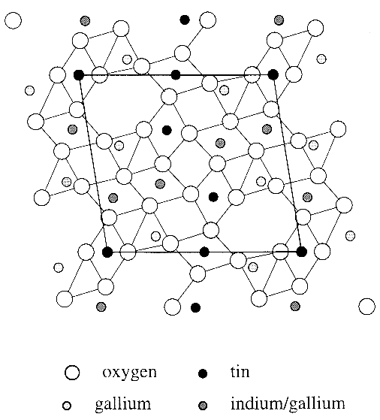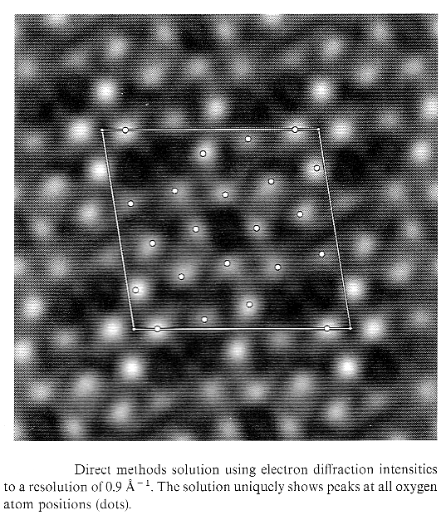

The potential map above right shows positions of only the light oxygen atoms. However, for other specimen thicknesses solution maps showed the positions of some of the heavy atoms, and other thicknesses resulted in a mix of the light and heavy atoms. Anyone who has done image simulation will know that this fluctuation of contrast is due to dynamical scattering. While in this case information about the structure was known from neutron diffraction, for completely new and unknown bulk structures the dynamical nature of the diffraction data can be very misleading or confusing. In the following example we will use the precession dataset taken from the a 50nm region of a powder particle (a wedge section with increasing thickness) to generate a structure map that is directly interpretable. In the exercise, we will allow direct methods to operate on only the intensities without a priori real space information. We ask it to generate phases from intensities alone starting from a very simple set of conditions.
Procedure

- Startup

- Make sure your path is set: $ export PATH=/usr/local/edm/bin:$PATH
  - If using csh or variants:
# setenv PATH /usr/local/edm/bin:$PATH

- Copy file 1540_8bpp.tif to the working directory

- CD into the working directory (you can also change into the working directory after starting EDM). Note that if you open a file in a different directory, the working directory will now be set to the folder where you opened the file.

- Start EDM using the command: $ edm

- Quantifying the dataset

- Open the image from the file menu.

- Check the “Log Scale” flag so that the weak reflections can easily be seen.

- Specify G1(5,0), G2(0,7), and G3(-3,-3) according to the following figure. For best accuracy when defining the lattice, it is advantageous to use high order reflections to accommodate distortions from the projector lens.

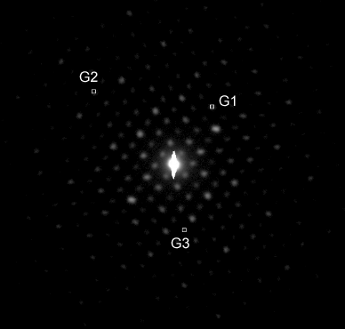

- Now that the lattice points are defined, use the “Find” button to locate the lattice. A grid of red and blue lines will appear. Each intersection point denotes a reflection position. If the lattice is not well-aligned (see below for comparison), redefine the lattice. The cross-correlation uses a small area about each intersection point to find peaks.

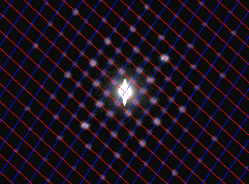

- With the lattice defined, the software is now ready to quantify intensities for you. First, set space “Group” to P2 so that it will know how to symmetrize the results.

- Set an appropriate “Threshold” for the peak-finding cross-correlation algorithm (default of 0.5 is fine for this dataset).
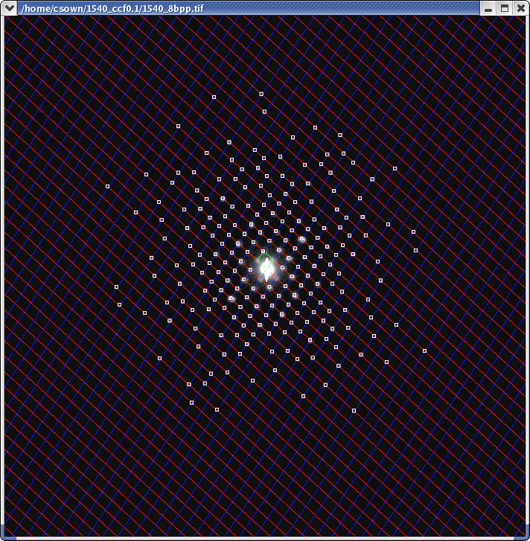
- Click "Find Peaks". A series of reflections will be highlighted (right). You can add or remove peaks from this set using the “+” and “–“ buttons on the main control panel. The peaks automatically found by the algorithm are sufficient for the purposes of this exercise.

- Click “Quantify/Symmetrize” to measure and tabulate the values of the reflections. During this operation, the reflections measured will be reduced according to P2 symmetry and normalized. A table will appear containing the values of the reflections (see figure below).
  - You can fill in the the “Phase” field if you know the phase for a particular reflection. If you know this phase is correct, check the “Use Phase” field to specify that it will stay fixed during the Genetic Algorithms calculation. In this calculation we will let DM vary all the phases and guess which phases work best.
  - Optional: Click "Show Ave Peak" and "Show Symm DP" to see the average peak motif used in the cross-correlation search and to see a DP generated using this motif.

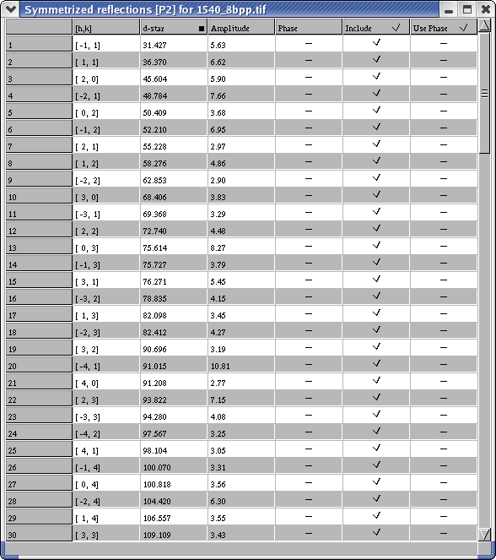

- Save the .hkl file that is generated as 1540_P2_ccf0.5.hkl. Use the “Save as HKL file…” option.
  - Note - it is useful to save the file using a <name>.<x>.hkl convention where <x> is some character or string. During the direct methods calculation, fs98 will change the contents of the hkl file but it will only parse characters up to the .<x>. Thus your original .hkl file will always be safe if the DM crashes or overwrites it.

- Running Direct Methods

- Click on the hkl table to focus it.

- In the control window, click on "Run Feasible Sets" in the "Direct Methods" menu.

- If you quantified the DP using EDM, it will have stored some unit cell information including 2-D plane group. The scaling factors may be wrong depending on whether you have calibrated to a real space image. At this time enter the unit cell parameters. (Since we are looking down [010], use these parameters: a = 10.73, b = 11.69, γ = 99°).

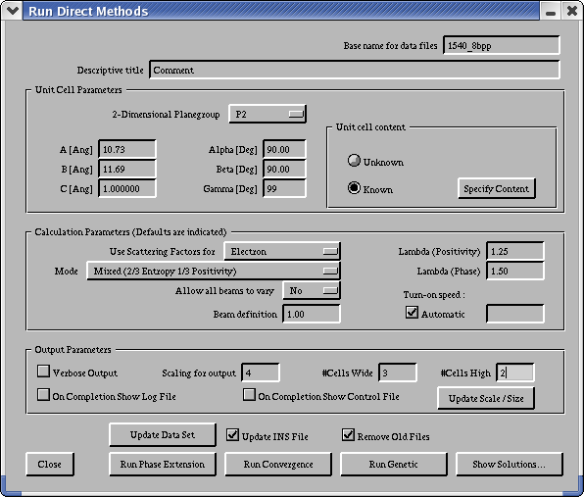

- At this time you can specify contents of the unit cell if the constituents are known, and also enter Debye-Waller factors which let DM know how delocalized some of the column potentials might be. Providing the number per unit cell of each type of atom gives the algorithm a clue as to how many peaks it should be looking for, but it will not necessarily find all of them, nor does this information tell the algorithm whether there is an overlap of atoms in the cell. For this exercise, we will leave these entries blank and let DM do the guessing for us.

- Click "Run Convergence". This will run a script that finds which beams likely define other beams. Usually you don't want this value to be too large (20% of the measured dataset is a good number) because these beams form the starting population. Too many starting variables make the calculation longer and may result in many false solutions.

- Next click "Run Genetic". The algorithm will take the starting set and propogate 36 child populations. Strong children (low FOM) will survive and weak children will die as the algorithm converges to the likely set of solutions.
  - Depending on the number of beams to be varied, the calculation can take anywhere from a few minutes to over an hour. On a dual-processor 3.06GHz Xeon, this data set varying 40 beams takes less than 10 minutes.

- Analysis

- Prior to analysis, select "Scaling for output"=4, "#cells Wide"=3, and "#cells High"=2 in the direct methods window. This specifies the display properties for the output which makes it easier to see what the solutions look like. Click "Update Scale/Size" to save this option.

- Click "Show Solutions" button.

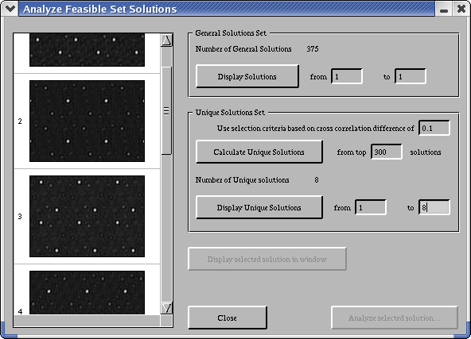

- You can display as many solutions as are generated (usually quite a lot) by using the "Display Solutions" button and controls. However, many of these solutions will be quite similar to each other.

- The program can sort through solutions to find unique solutions representative of solution families for you. Press the "Calculate Unique Solutions" button to find solutions that are unique based on the cross correlation criterion (lower = looser constraints). The number of unique solutions found will be displayed.

- It is worthwhile to look at all the unique solutions found if there are not too many. In this case, there are 23 solutions (you may or may not get the same number, depending on how you quantified the intensities and ran the code). View solutions 1 through 23 and press “Display unique solutions”.
    - Looking at the images that are displayed on the left you might notice that many of them are quite similar. You can narrow down the field by increasing the cross correlation threshold to 0.1 (default = 0.05). This reduces the number of unique solutions to 8 which is more manageable. However, norrowing down the field too much may exclude solutions you might be interested in seeing.

- You can view each selection in its own window at full size by selecting it fom the scroll window and pressing "Display selected solution in window".
- The images are outputted with a 90° cell. For materials with non-rectangular lattices you will have to skew them to compare with other models.
- The images are outputted as .tif files and can be viewed and edited in common programs. Sometimes the details are quite subtle and it is worthwhile to examine the map more closely by adjusting brightness and contrast in an image editing program and by using contour maps. Often most of the intensity in the image is distributed in a small range of the histogram; mapping the dynamic range of the image to the intensities of interest will make things easier to see:

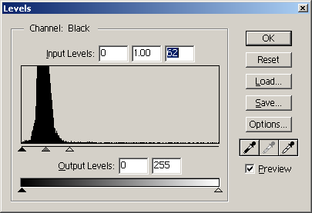
Discussion

All solutions generated from this dataset have an easily-identifiable framework formed by the corner Sn ions. White peaks denote atom positions. There are two ions per unit cell in projection, thus the corner atoms are regions of high potential. From this point, one seeks solutions that make physical sense. A subsequent refinement to improve the fit of the intensity data with the selected structure maps is generally conducted after a potential solution is found (a very complex procedure; this functionality not included in EDM and will not be discussed here). While in this case the structure is known, we remind you that throughout the process of studying an unknown structure, you must always check that the proposed structure makes chemical and physical sense.

For this dataset, there are three major families of solutions that the code finds (see figure below). The first (a) is the main structure with most cations well localized, except one of the two Sn ions in the center has too little potential. A second family (b) is the main structure minus the middle Sn ion along the cell edge. The last family contains all the Sn cations, and various maps from this family locate most or all of the lighter cations. This demonstrates an important point: given a good data set, direct methods will find the right solution. It is the end user who must sort through the possible solutions and interpret which of the solutions is the true solution. The code will not find the solution for you; it is a tool that will point you in the right direction.

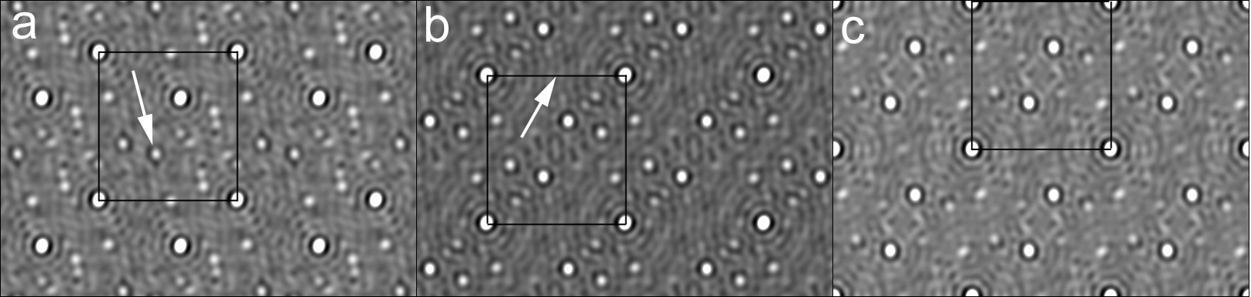

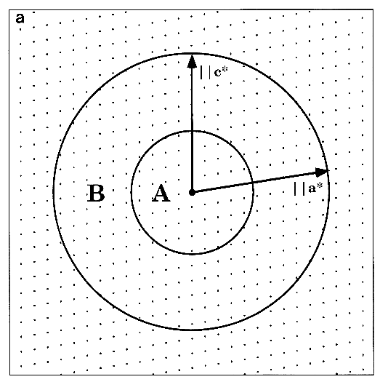
The striking thing about this precession dataset is that the potential, while not accurate in absolute intensity, does give accurate information about the cation positions and also the relative density in the columns. For example, all of the maps in the third solution family contain accurate positional information about the heaviest cation, Sn. The In/Ga columns have less well-defined potential, but due to the occupancy of In, are still easily discernable. Two of four Ga cations per unit cell are too faint to see in some potential maps, but light image processing shows that they are present and not part of the background in many solutions.

A solution using a very large number of reflections (over 625) is shown on the next page with a skewed model from Sinkler, et. Al. for comparison. The calculation is very lengthy and does not yield more information than the 125-reflection dataset above. While the solution contains some more fine detail, the extra higher-order reflections do not contribute to the important features of the structure, which are defined primarily by a small annulus of reflections between 0.4 and 0.9 A (right). Additionally, most high-order reflections are close to the noise floor intensity and are probably not accurately quantified.
